FINAL EXAMINATION 2024-2025
SUB – MATHEMATICS
CLASS- IX DATE – 24/02/25 MM: 80
General Instructions:
1. This Question Paper has 5 Sections A-E.
2. Section A has 20 MCQs carrying 1 mark each
3. Section B has 5 questions carrying 02 marks each.
4. Section C has 6 questions carrying 03 marks each.
5. Section D has 4 questions carrying 05 marks each.
6. Section E has 3 case based integrated units of assessment (04 marks each) with sub-parts of the values of
1, 1 and 2 marks each respectively.
7. All Questions are compulsory. However, an internal choice in 2 Qs of 5 marks, 2 Qs of 3 marks and 2
Questions of 2 marks has been provided. An internal choice has been provided in the 2marks questions of Section E
8. Draw neat figures wherever required. Take x=22/7 wherever required if not stated.
SECTION -A
Multiple choice questions:
1) ( $\frac{2}{3}$ )^{x} ( $\frac{3}{2}$ )^{2x} = $\frac{81}{16}$
a. -4 b. 4 c. 6 d. 8
2) Which of the following is an irrational number?
a. √23 b. √225 c. 0.3796 d. 7.478478
3) If x²+kx+6 = (x+2)(x+3) for all k, find the value of k.
a. -1 b. 1 c. 3 d. 5
4) The value of f(x) = 5x−4x²+3 when x = -1, is:
a. 3 b. -12 c. -6 d. 6
5) The point which lies on the y-axis at a distance of 5 units in the negative direction of the y-axis is
a. (5, 0) b. (0, 5) c. (-5, 0) d. (0, -5)
6) Find the value of k, if x = 1, y = 2 is a solution of the equation 2x + 3y = k.
a. 5 b. 6 c. 7 d. 8
7) Axioms are assumed
a. Theorems b. Definitions
c. Universal truths specific to geometry d. Universal truths in all branches of mathematics
8) An exterior angle of a triangle is 105° and its two interior opposite angles are equal. Each of these equal
angles is
a. 37 ½° b. 72 ½° c. 75° d. 52 ½°
9) If ∆ ABC ≅ ∆ PQR, then which of the following is not true?
a. AC = PR b. BC = PQ c. QR = BC d. AB = PQ
10) It is given that ∆ ABC ≅ ∆ FDE and AB = 5 cm, ∠B = 40° and ∠A = 80°. Then which of the following is
true?
a. DF = 5 cm, ∠F = 60° b. DF = 5 cm, ∠E = 60°
c. DE = 5 cm, ∠E = 60° d. DE = 5 cm, ∠D = 40
11) ABCD is a rhombus such that ∠ACB = 40º. Then ∠ADB is
a. 40º b. 45º c. 50º d. 60º
12) If angles A, B, C and D of the quadrilateral ABCD, taken in order, are in the ratio 3:7:6:4, then ABCD is a
a. Kite b. Rhombus c. Parallelogram d. Trapezium
13) If AB = 12 cm, BC = 16 cm and AB is perpendicular to BC, then the radius of the circle passing through the points A, B and C is:
a. 6 cm b. 8 cm c. 10 cm d. 12 cm
14) The sides of a triangle are in the ratio 12: 17: 25 and its perimeter is 540 cm. The area is:
a. 1000 sq.cm b. 5000 sq.cm c. 9000 sq.cm d. 8000 sq.cm
15) The radius of a hemispherical balloon increases from 6 cm to 12 cm as air is being pumped into it. The ratio
of the surface areas of the balloon in the two cases is
a. 1:4 b. 1:3 c. 2:3 (d) 2:1
16) The total surface area of a cone whose radius is r/2 and slant height 2l is
a. 2πr(l+r) b. πr(l+(r/4)) c. πr(l+r) d. 2πrl
17) If $a^{2}+b^{2}{+ c}^{2}$ = 30 and a + b + c = 10, then the value of ab + bc + ca is:
a. 25 b. 30 c. 35 d. 40

18) If x + y =15 then x + y + z = 15 + z. Then the Euclid’s axiom that illustrates this statement is:
a) First axiom b) Second axiom c) Third axiom d) Fourth axiom

Directions: Choose the correct answer out of the following choices :
(a) Assertion and Reason both are correct statements and Reason is the correct explanation of Assertion.
(b) Assertion and Reason both are correct statements but Reason is not the correct explanation of Assertion.
(c) Assertion is correct statement but Reason is wrong statement.
(d) Assertion is wrong statement but Reason is correct statement.
19) Assertion: According to Euclid’s 1st axiom- “Things which are equal to the same thing are also equal to one
another”.
Reason: if AB = PQ and PQ = XY, then AB = XY
20) Assertion: If x = 2k – 1 and y = k is a solution of the equation 3x – 5y – 7 = 0, then the value of k is 10.
Reason: A linear equation in two variables has infinitely many solutions
SECTION-B
21) Factorise: 8a³ – b³ – 12a²b + 6ab²
22) If (p, 2p + 1) is the solution of the linear equation 4x + 3y = 23. Find the value of p.
23) In fig. AC = XD, C is the mid-point of AB and D is the mid-point of XY. Using a Euclid's axiom, show
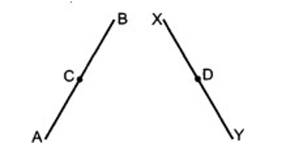
that AB = XY.

24) In given figure, if OP||RS, ∠OPQ = 110° and ∠QRS = 130°, then find ∠PQR
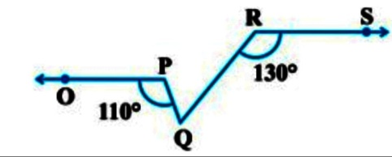

OR
In the given figure AB ||CD. Prove that p + q – r = 180°
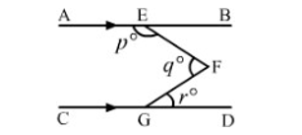

25) The radius and slant height of a cone are in the ratio 4:7 if the curved surface area is 792 cm² find its radius.
OR
Find the radius of sphere whose surface area is 616 cm²
SECTION-C
26) Represent $\sqrt{6.3}$ on the number line
OR
Simplify $\frac{\sqrt{5}-2}{\sqrt{5}+2}$ = a+b$\sqrt{5}$ find the value of a and b
27) Factorise: a³-b³ +1+3ab
28) In fig find the vertices' co-ordinates of △ABC
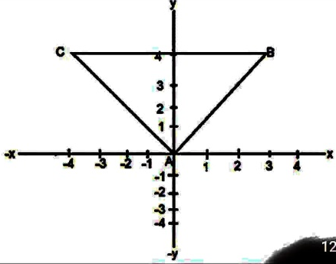

29) In given figure, it is given that AB = CF, EF = BD and ∠AFE = ∠CBD. Prove that ΔAFE$≅$ ΔCBD
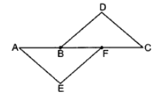

OR
In given figure, AD and BE are respectively altitudes of a triangle ABC such that AE = BD. Prove that
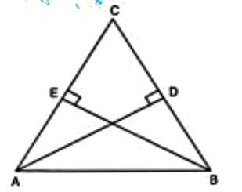
AD = BE.

30) In figure, OA and OB are respectively perpendiculars to chords CD and EF of a circle whose centre is O. If
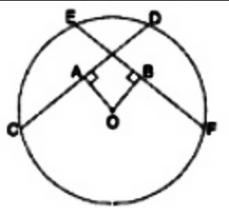
OA = OB, prove that EC=DF

31) The triangular side walls of a flyover have been used for advertisements. The sides of the walls are 13 m, 14 m and 15 m. The advertisements yield an earning of Rs2000 per m² a year. A company hired one of its walls for 6 months. How much rent did it pay?
SECTION-D
32) The volume of a sphere is 38808 cm³ , find its surface area.
33) (i) Verify: x³ + y³ = (x+y) (x² -xy +y²)
(ii) Give possible expressions for the length and breadth of the following rectangle, the area of which is
given as: Area: 25a² - 35a + 12.
34) Twenty seven solid iron spheres each of radius r and surface area S are melted to form a sphere with surface
area S’. Find the
(i) radius r’ of the new sphere (ii) ratio of S and S’
OR
A hemispherical dome of a building needs to be painted. If the circumference of the base of the dome is 17.6m, find the cost of painting it, given the cost of painting is Rs.5 per 100cm².
35) 100 surnames were randomly picked up from a local telephone directory and a frequency distribution of the number of letters in the English alphabet in the surnames was found as follows:
Number of letters | Number of surnames
1 – 4 | 6
4 – 6 | 30
6 – 8 | 44
8 – 12 | 16
12 – 20 | 4

- Draw a histogram to depict the given information.
- Write the class interval in which maximum number of surnames lie.
OR
The following table gives the distribution of students of two sections according to the marks obtained by them:
Section A |  | Section B
Marks | Frequency | Marks |  | Frequency
0 - 10 | 3 | 0 - 10 | 5
10 - 20 | 9 | 10 - 20 | 19
20 – 30 | 17 | 20 – 30 | 15
30 – 40 | 12 | 30 – 40 | 10
40 - 50 | 9 | 40 - 50 | 1

Represent the marks of the students of both the sections on the same graph by two frequency polygons. From the two polygons compare the performance of the two sections.
SECTION-E (Case Study Based Questions)
36) Case Study -1
A farmer has a circular garden as shown in the picture below. In the garden, there are two mango trees A and B at a distance of AB = 10m. Similarly, has two Ashok trees at the same distance of 10m as shown at C and D.
AB subtends AOB = 120° at the center O. The perpendicular distance of AC from the center is 5m and the
radius of the circle is 13m. Based on this information answer the following questions:
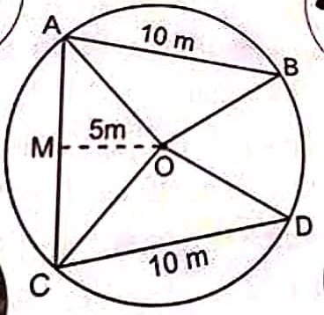

- What is the value of COD? (1)
- What is the value of OAB ? (1)
- What is the distance between mango tree A and Ashok tree C? (2)
37) Case Study-2
In an activity period , class teacher gave students coloured paper in the shape of a quadrilateral. She asks them make a parallelogram from it using paper folding.
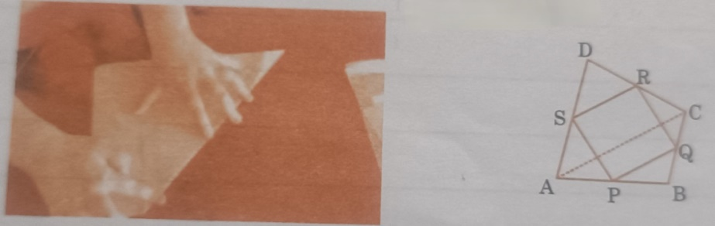

- Show that SR ║ AC and SR = $\frac{1}{2}$ AC (1)
- Prove that PQRS is a parallelogram. (2)
- If one angle of a parallelogram is 108°, find the remaining three angles? (1)
38. Case Study – 3
Teachers and students of class IX of a school had gone to Nandan Kannan for study tour. After visiting different places of Nandan Kannan, lastly, they visited birds sanctuary and deer park. Rohan is the clever boy and keen observer. He put the question to his friends,”How many birds are there in Nandan Kannan?”Rahul’s friend, Nishith gave the the correct answer as follows:
‘Nishith answered that total animals have 1000 eyes and 1400 legs.’
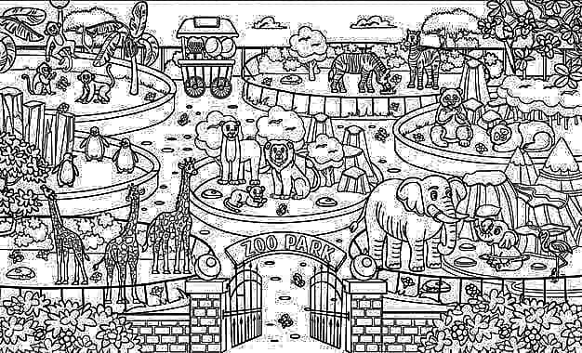

- If x and y be the number of birds and deer respectively, write the linear equation of total number of eyes? (1)
- Write the equation for the total number of legs? (1)
- How many birds are there in the zoo? (2)

